Group 8 portfolio

Project Briefs, Hypothesis, business and user assumptions:

Austin

Ted

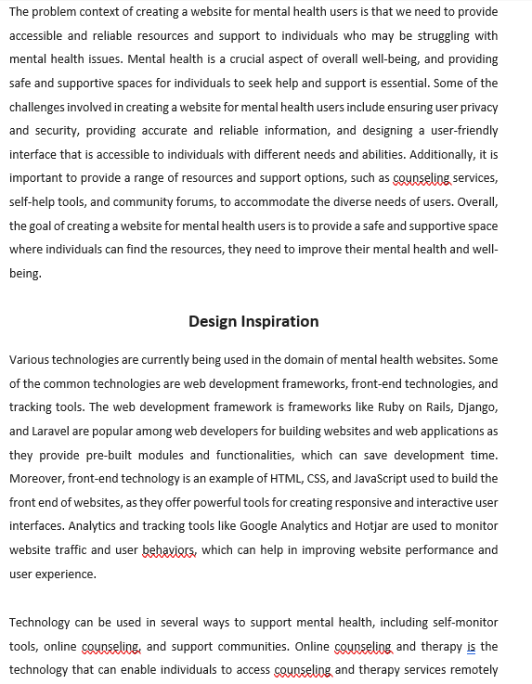

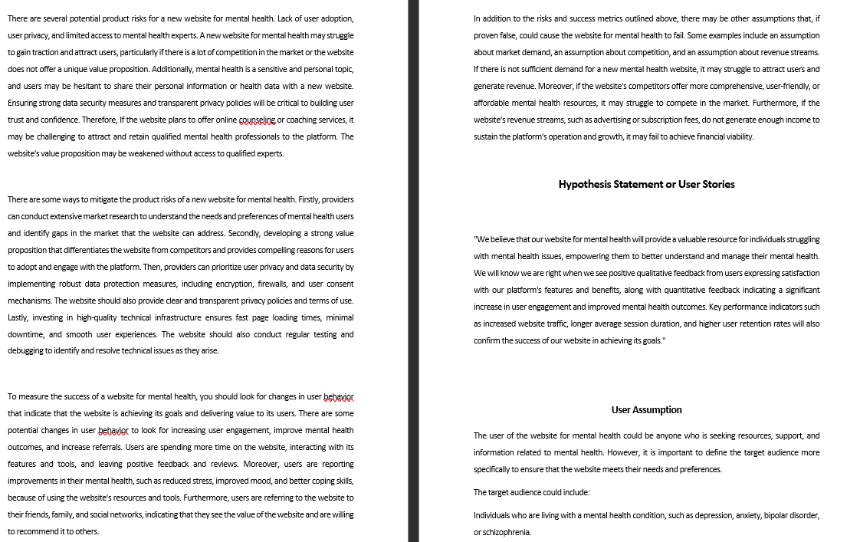

Mayooran



